**Basic Labs**

1. **EC2 Basics Lab**
   * **Objective**: To understand the process of setting up and managing an Amazon EC2 instance.
   * **Approach**: Students will start by launching a new EC2 instance, selecting an appropriate instance type and configuring the instance details. They will then create and configure a new Security Group, and allocate an Elastic IP address to the instance. The lab will also include connecting to the instance via SSH.
   * **Goal**: By the end of this lab, students should be able to launch and manage an EC2 instance, understand instance types, security groups, and IP addressing in AWS.
2. **S3 Storage Fundamentals Lab**
   * **Objective**: To gain hands-on experience with Amazon S3 by performing basic storage operations.
   * **Approach**: This lab involves creating an S3 bucket, uploading files to it, and setting up bucket policies for access control. Students will explore the S3 management console, learn about object storage, and understand the concepts of buckets and objects.
   * **Goal**: Students will understand how to use S3 for storing and managing data, learn about S3 security and permissions, and become familiar with S3's user interface.
3. **IAM Users and Roles Lab**
   * **Objective**: To understand AWS Identity and Access Management (IAM) by creating and managing users, groups, and roles.
   * **Approach**: Students will create new IAM users, assign them to groups, and apply policies to manage permissions. The lab will also involve creating roles for AWS services and understanding the use of IAM roles for cross-service access.
   * **Goal**: Students will learn about user and permission management in AWS, the importance of roles for security and best practices for IAM.

# EC2 Basics Lab

Go to EC2 from AWS CONSOLE

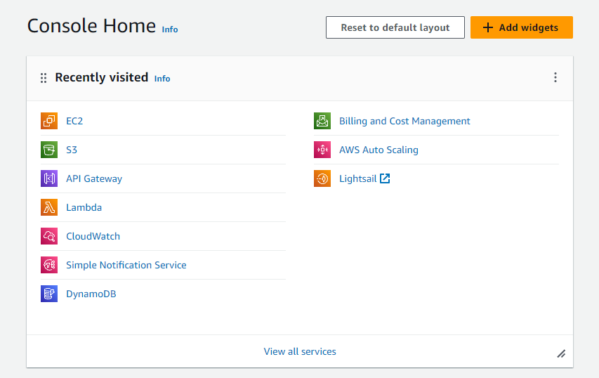

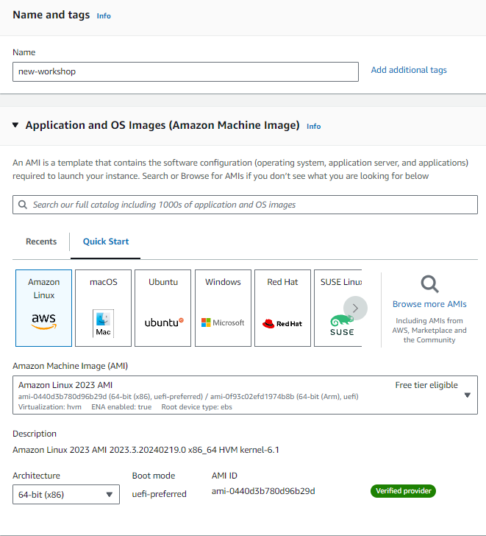

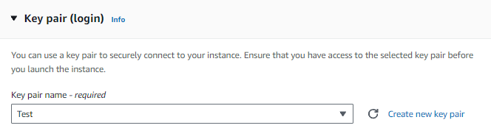

Create and launch Ec2 Instance

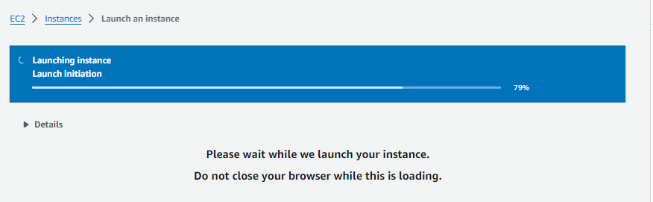

Click on Instances you can find the new created instances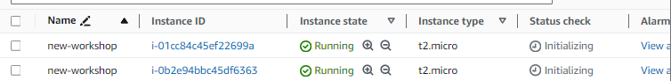

Now allocate an Elasic IP address to this instance

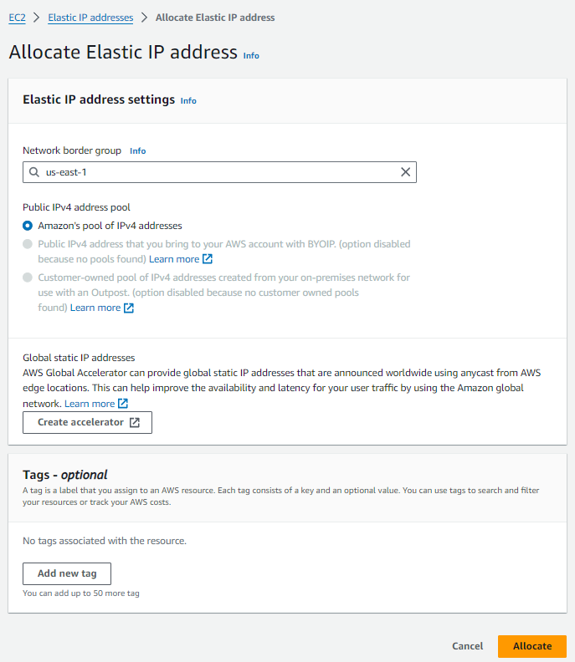

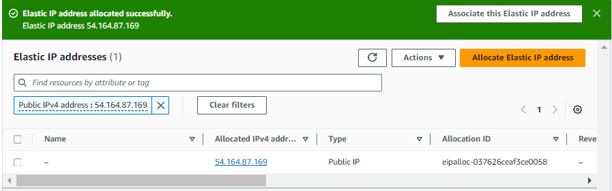

So that Elastic IP address has been allocated

Open the created IP Address.

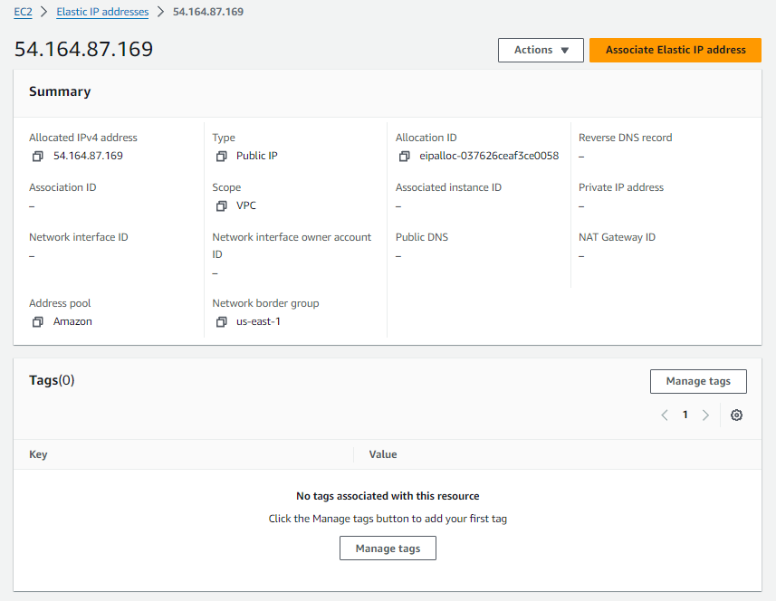Click on Associate Elasic IP Address

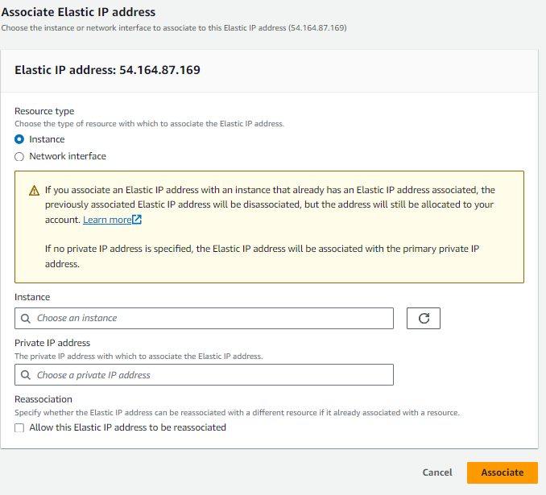

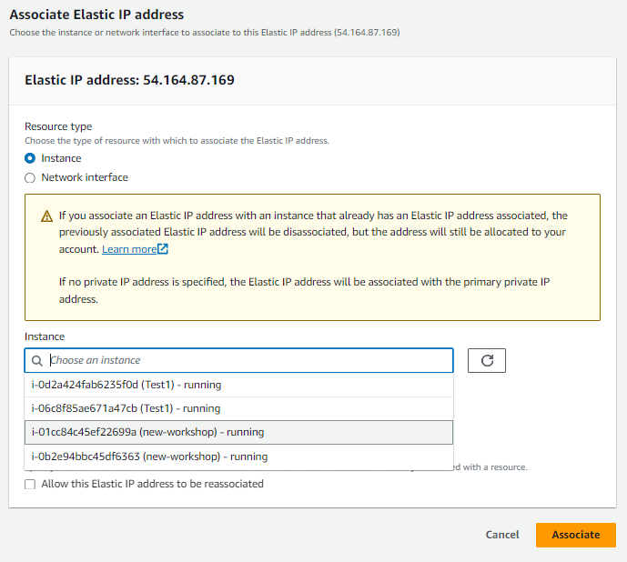

Now choose the Instance that we created previously .

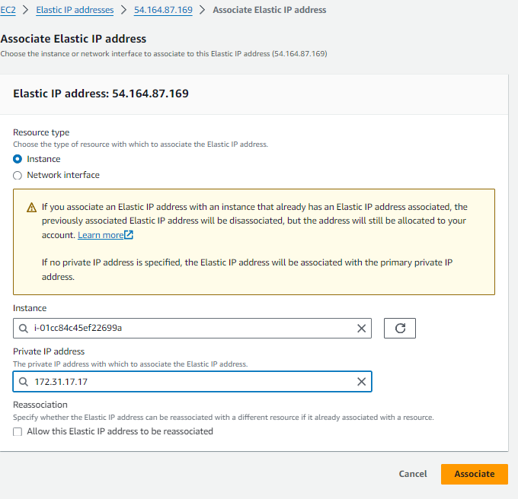

Now click on assosciate button after assigning private IP address

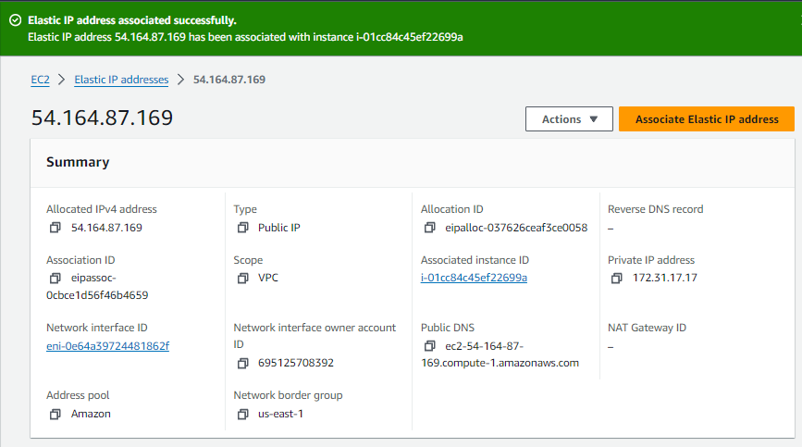

Now Elascitc IP is finally showing in our EC2 Instance

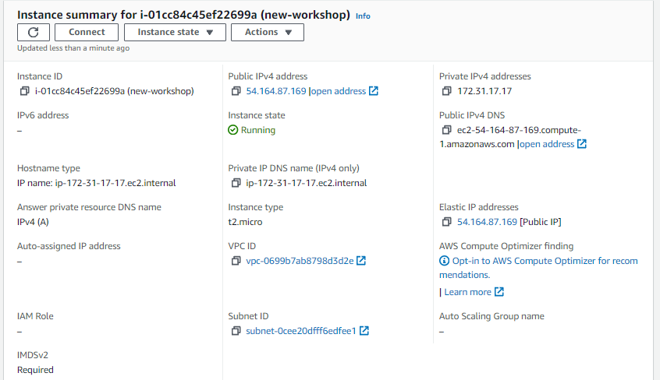

Now we have to connect the instance via SSH

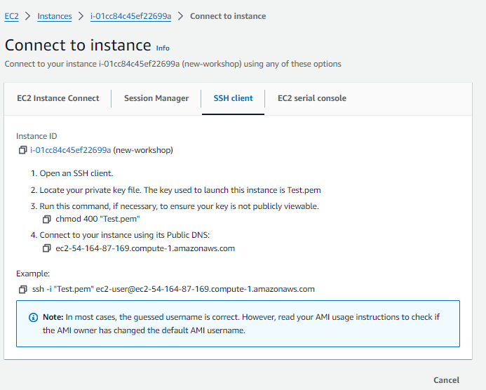

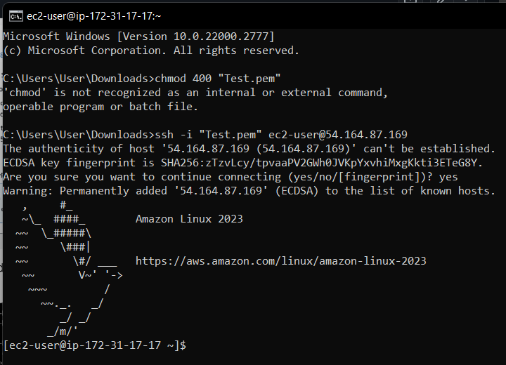

Connection Success of EC2 Instance via SSH Key.

# S3 Storage Fundamentals Lab

First Create a S3 Bucket

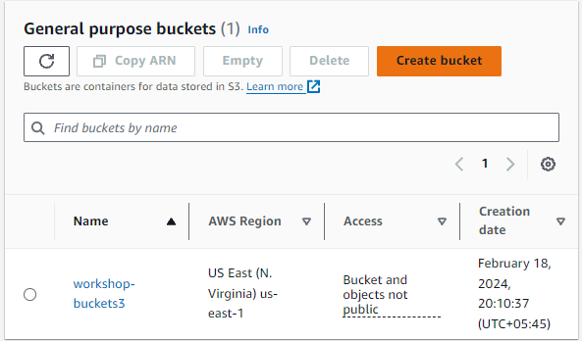

Click on Create Bucket

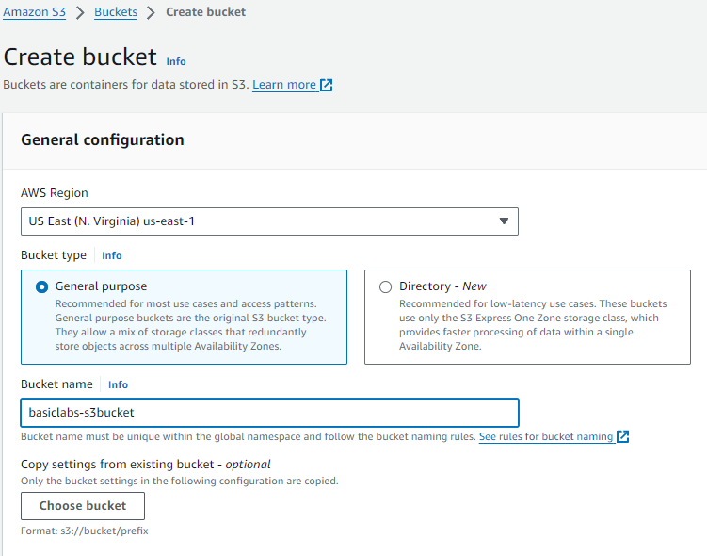

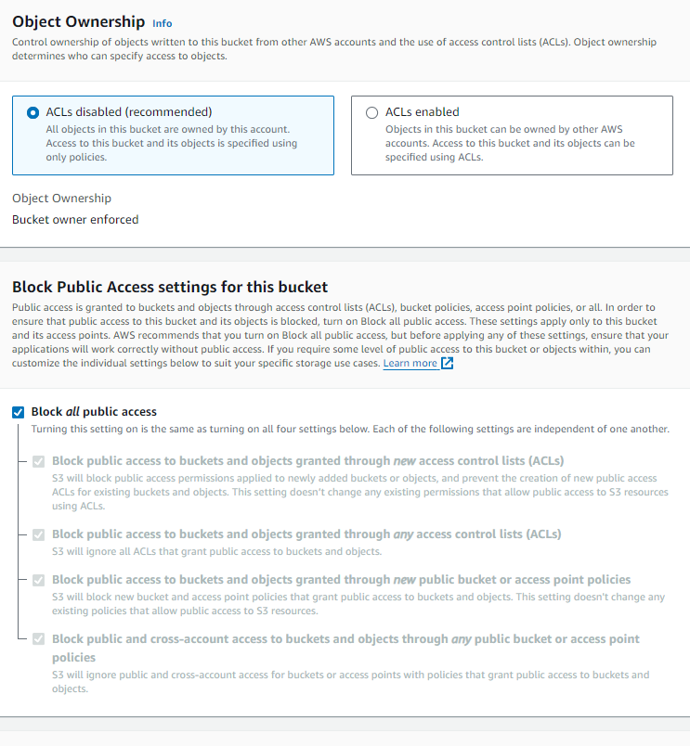

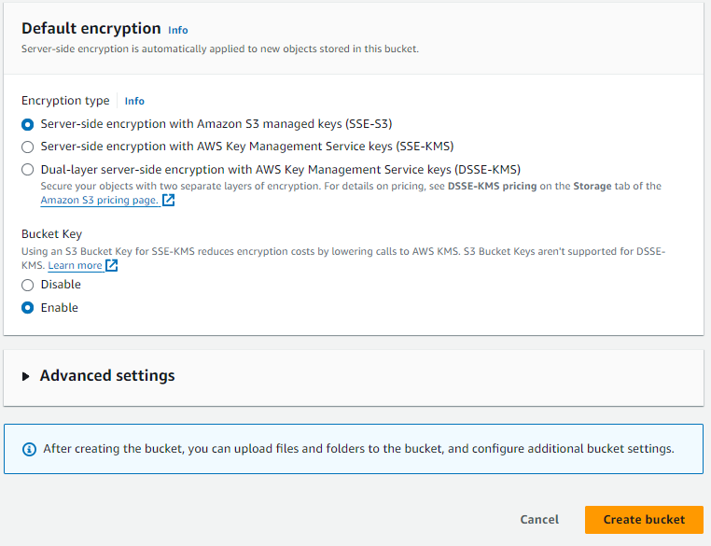

Set bucket name and leave the rest as it is and click on Create Bucket

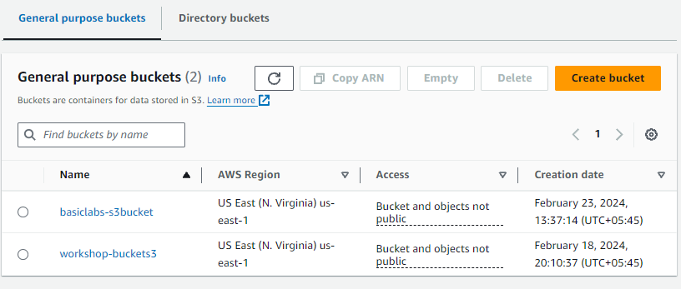

So the New bucket has been created with the name basiclabs-s3bucket

Now the next task will be to Upload files

To upload files click on the new bucket that we just created.



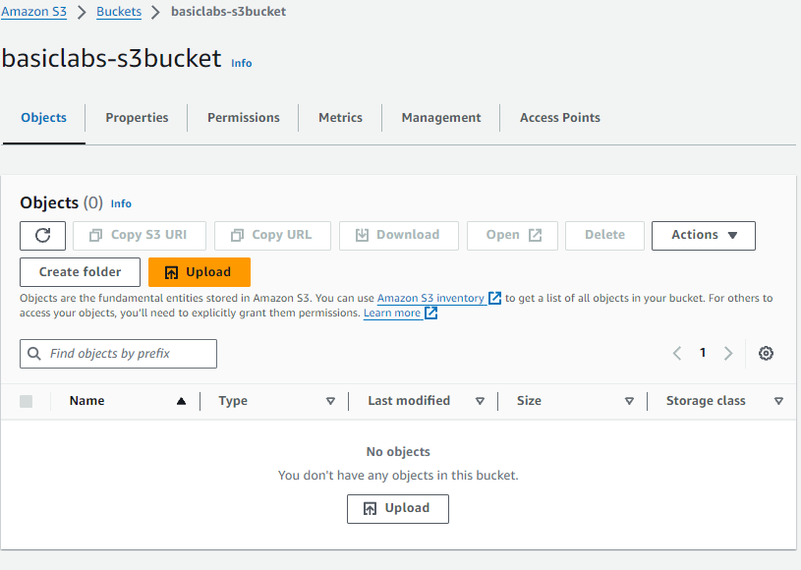

Then click on upload button

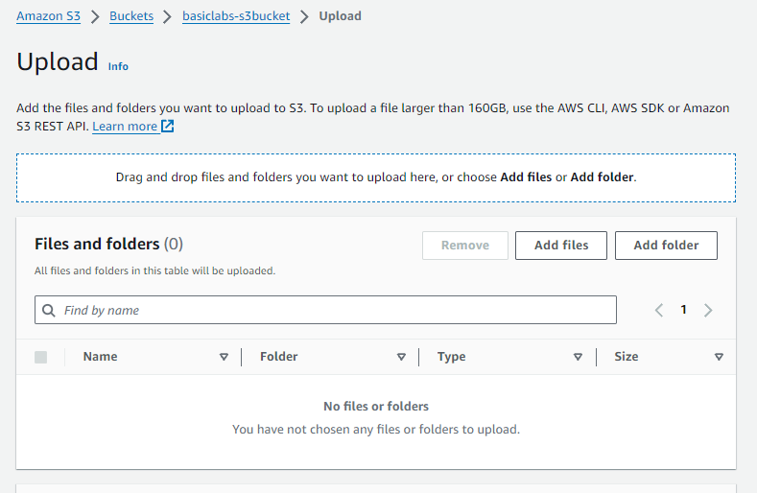

Then drag and drop file to be uploaded

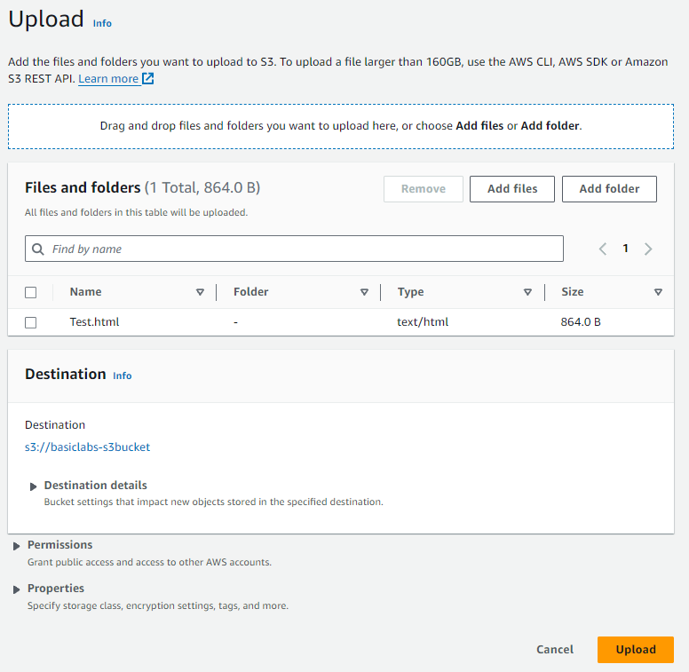

Now upload the file .

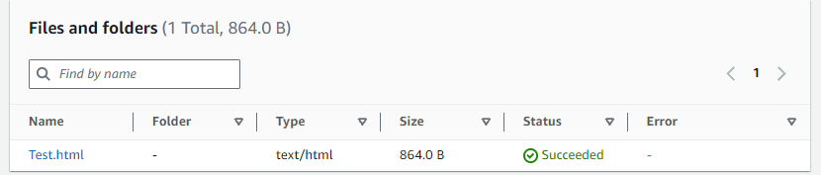

Detail of the uploaded file can be viewed by clicking on It.

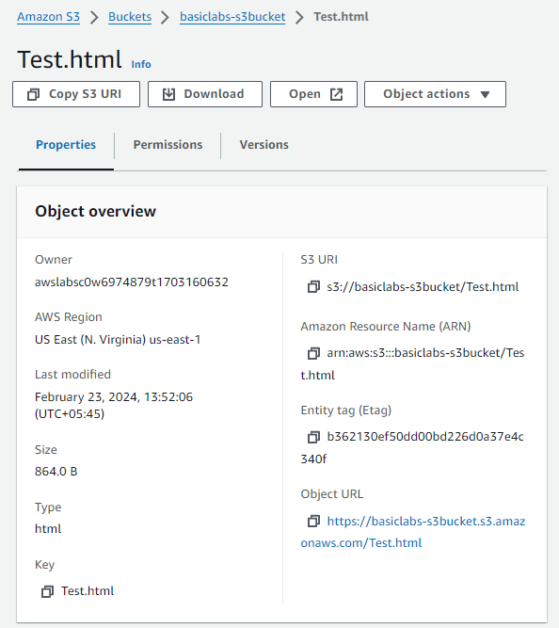

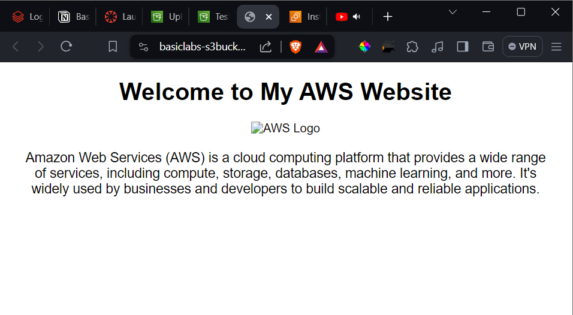

Uploaded file can be accessed by clicking on the open button on the object overview page.

# Setting up bucket policies for Access Control

Click on Permissions of the bucket we created.

# 

Click on Edit Bucket and then policy Generator which will redirect you to the new page.



 